**Lean-based Lab Experimentation**

**Soniah N**

**192311012**

# Setting Up in Jira

1. **Define a Custom Issue Type**
   * **Name**: Experiment
   * **Description**: For tracking lean experiments focused on validating hypotheses and iterating on product features.

**Fields for the Issue Type:**

1. **Experiment Type**:

○ Dropdown options: MVP, A/B Test, Customer Feedback Test, etc.

1. **Hypothesis**:

○ Text field for stating the hypothesis (e.g., "We believe that adding X will result in Y").

1. **Metrics to Measure**:

○ Multi-select field for metrics (e.g., Click Rate, Sign-up Rate, Revenue Impact).

1. **Status**:

○ Options: Identify Hypothesis, Build MVE, Measure, Learn, Decide.

1. **Findings**:

○ Text area to document results and learnings from the experiment.

1. **Decision**:

○ Options: Implement, Pivot, Discard, Retry.

1. **Design the Workflow** ● **Steps/Statuses**:

○ **Identify Hypothesis**: Clearly articulate the hypothesis.

○ **Build MVE**: Develop the minimal testable version of the solution.

○ **Measure**: Run the experiment and collect data.

○ **Learn**: Analyze the results to validate or invalidate the hypothesis.

○ **Decide**: Make a final decision (Implement, Pivot, Discard). ● **Transitions**:

○ Allow movement between all statuses to accommodate flexibility (e.g., Measure → Identify Hypothesis for refinement).

1. **Create a Workflow Template**

## Identify Hypothesis

* **Task**: Define a clear hypothesis.
* **Example**:

○ Hypothesis: "We believe that changing the button color to green will increase the click-through rate by 10%."

* **Exit Criteria**: Hypothesis is documented and reviewed.

## Build MVE

* **Task**: Develop a minimal solution to test the hypothesis.
* **Example**:

○ Build a simple prototype or enable a feature for A/B testing.

* **Exit Criteria**: MVE is deployed and ready for testing.

## Measure

* **Task**: Run the experiment with users.
* **Example**:

○ Collect data such as click rates or user feedback.

* **Exit Criteria**: Metrics are collected and documented.

## Learn

* **Task**: Analyze results to validate or invalidate the hypothesis.
* **Example**:

○ Result: "Changing the button color increased click rates by 15%, validating the hypothesis."

* **Exit Criteria**: Findings are documented.

## Decide

* **Task**: Based on findings, decide the next step.
* **Options**:

○ Implement: Roll out the feature.

○ Pivot: Adjust and retest.

○ Discard: Stop pursuing the idea.

* **Exit Criteria**: Decision is documented and shared.

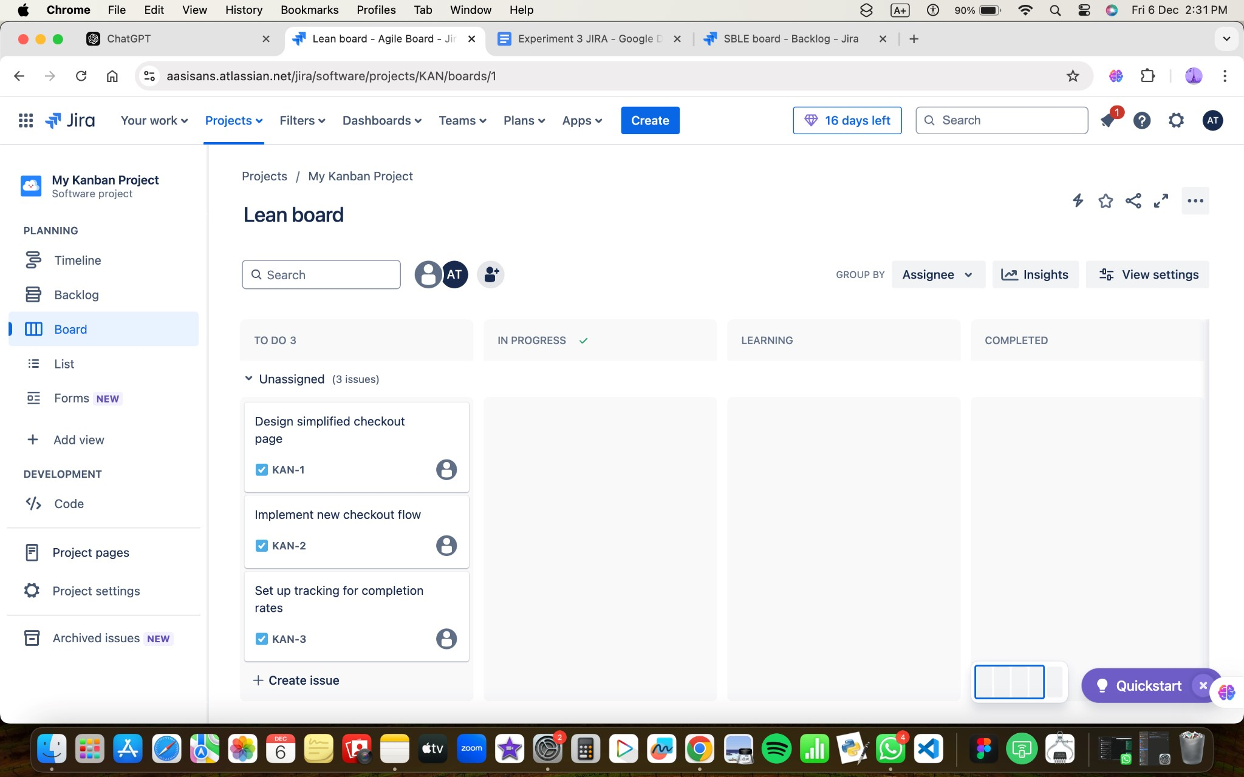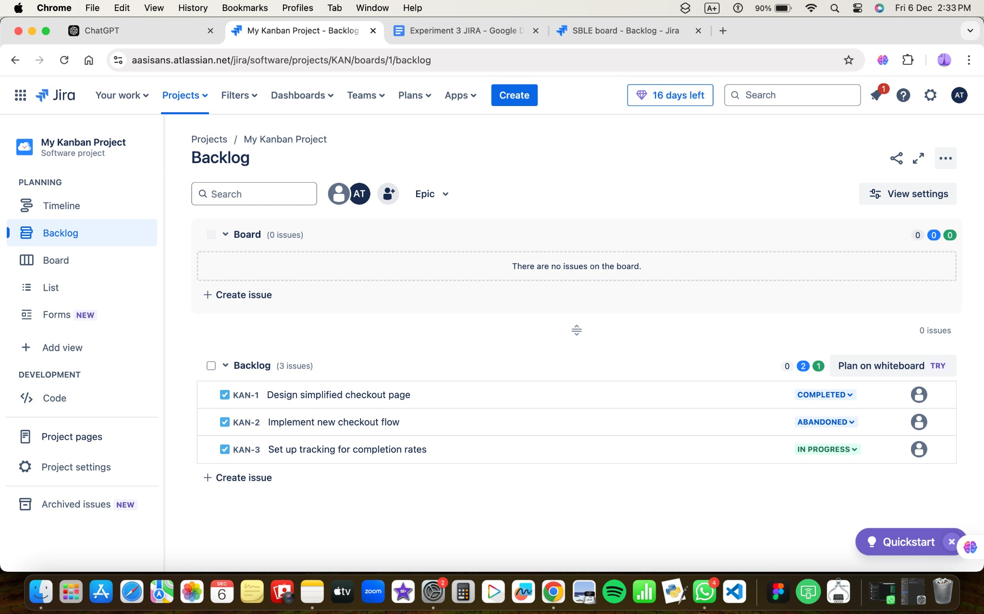

# Using the Workflow in Jira

1. **Create a New Issue**:
   1. Select the issue type "Experiment."

○ Fill in the fields (Hypothesis, Experiment Type, Metrics, etc.).

1. **Track Progress**:
   1. Move the issue through the statuses: Identify Hypothesis → Build MVE → Measure → Learn → Decide.
2. **Document Learnings**:
   1. Use the **Findings** and **Decision** fields to record outcomes.
3. **Monitor Metrics**:
   1. Attach dashboards or reports to track experiment-related metrics over time.

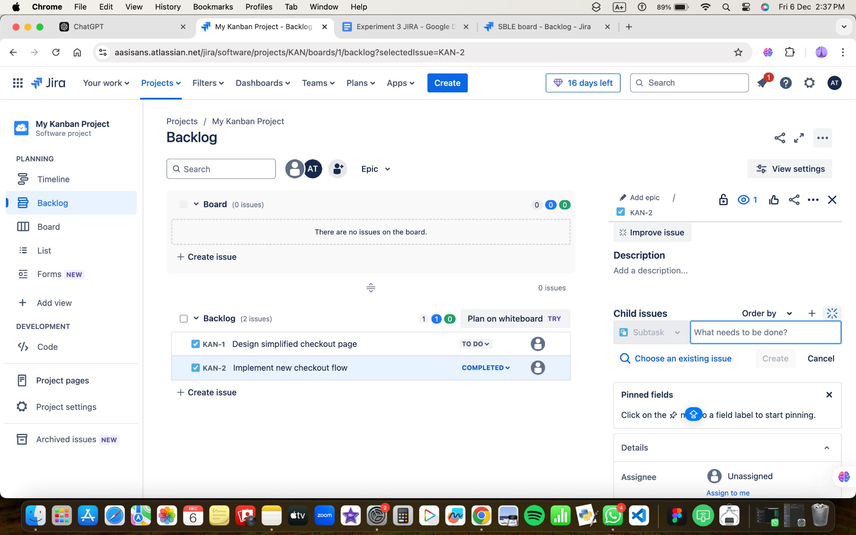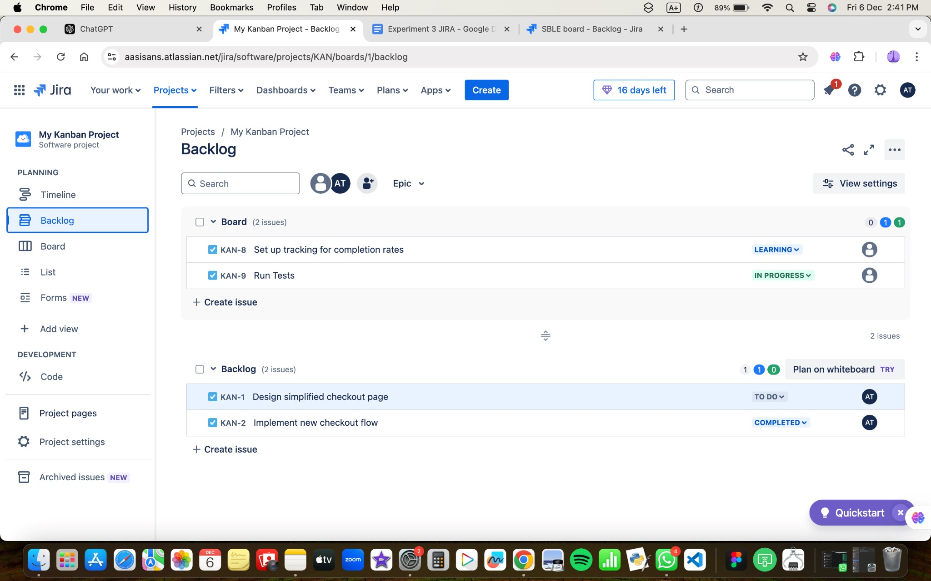

# Example in Practice

**Issue Summary:**

**Experiment Type**: MVP for New Feature

**Hypothesis**: Adding a "Quick Checkout" option will reduce cart abandonment. **Metrics to Measure**: Abandonment Rate, Checkout Completion Rate

**Workflow:**

1. **Identify Hypothesis**:
   1. Document hypothesis.
2. **Build MVE**:
   1. Add a "Quick Checkout" option to the UI.
3. **Measure**:
   1. Deploy feature to a small segment, track abandonment and completion rates.
4. **Learn**:
   1. Data shows a 20% decrease in cart abandonment.
5. **Decide**:
   1. **Decision**: Implement the feature for all users.

This process ensures experiments are well-documented, iterative, and aligned with lean principles while leveraging Jira to maintain visibility and accountability. Would you like assistance in creating custom fields or workflows in Jira?

